Kortudsnit fra NetBas

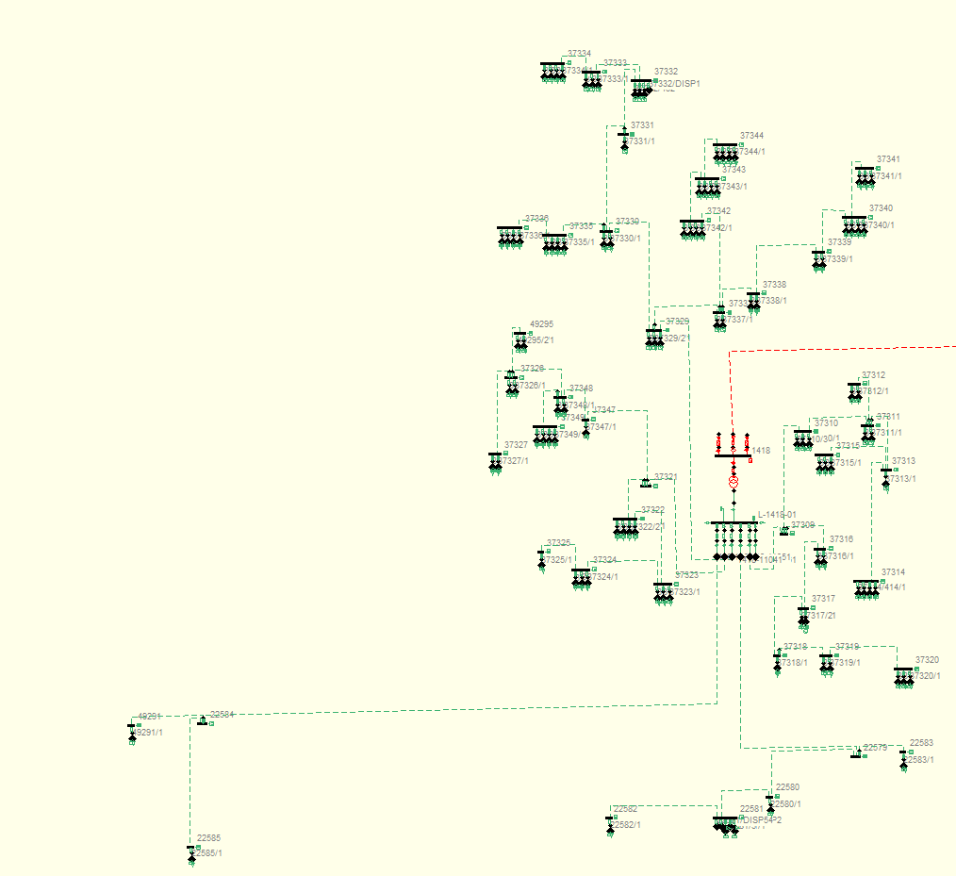

Kortudsnit fra WebGis

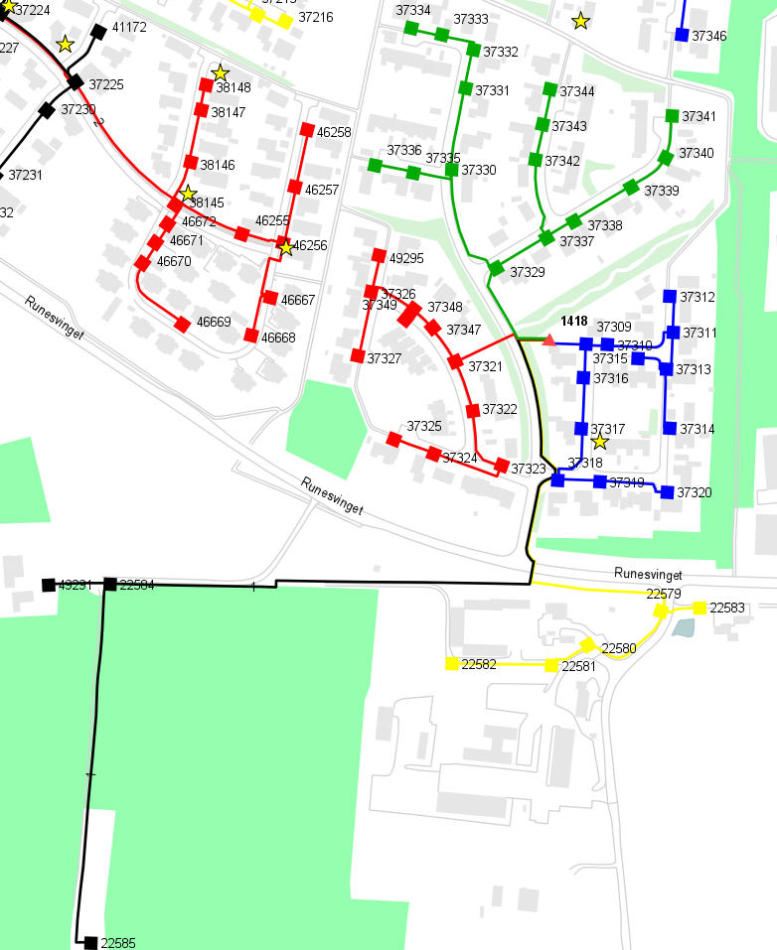

Kabeldata

|  |  |  |  |  |
| --- | --- | --- | --- | --- |
| Knudepunkt 1 | Knudepunkt 2 | Længde | Tværsnit | Type |
|  |  | km | mm2 |  |
| 1418-11011 | 22584 | 0.581 | 150 | PEX |
| 22584 | 22585 | 0.305 | 150 | PEX |
| 1418-11021 | 37321 | 0.085 | 150 | PEX |
| 37347 | 37348 | 0.023 | 95 | PEX |
| 37326 | 37348 | 0.044 | 95 | PEX |
| 37322 | 37323 | 0.059 | 95 | PEX |
| 37323 | 37324 | 0.065 | 95 | PEX |
| 37324 | 37325 | 0.036 | 95 | PEX |
| 1418-11031 | 37329 | 0.092 | 150 | PEX |
| 37329 | 37330 | 0.100 | 150 | PEX |
| 37330 | 37331 | 0.068 | 150 | PEX |
| 37332 | 37333 | 0.034 | 95 | PEX |
| 37333 | 37334 | 0.027 | 95 | PEX |
| 37330 | 37335 | 0.040 | 50 | PVIK |
| 37335 | 37336 | 0.033 | 50 | PEX |
| 37338 | 37339 | 0.055 | 95 | PEX |
| 37339 | 37340 | 0.039 | 95 | PEX |
| 37340 | 37341 | 0.036 | 95 | PEX |
| 37342 | 37343 | 0.031 | 95 | PEX |
| 37343 | 37344 | 0.031 | 95 | PEX |
| 1418-11041 | 22579 | 0.360 | 95 | PEX |
| 22579 | 22580 | 0.082 | 95 | PEX |
| 22580 | 22581 | 0.038 | 95 | PEX |
| 22581 | 22582 | 0.083 | 95 | PEX |
| 1418-11051 | 37309 | 0.032 | 150 | PEX |
| 37310 | 37311 | 0.062 | 95 | PEX |
| 37313 | 37314 | 0.053 | 50 | PEX |
| 37313 | 37315 | 0.031 | 50 | PEX |
| 37316 | 37317 | 0.043 | 95 | PEX |
| 37317 | 37318 | 0.057 | 95 | PEX |
| 37319 | 37320 | 0.060 | 50 | PEX |

Transformerdata

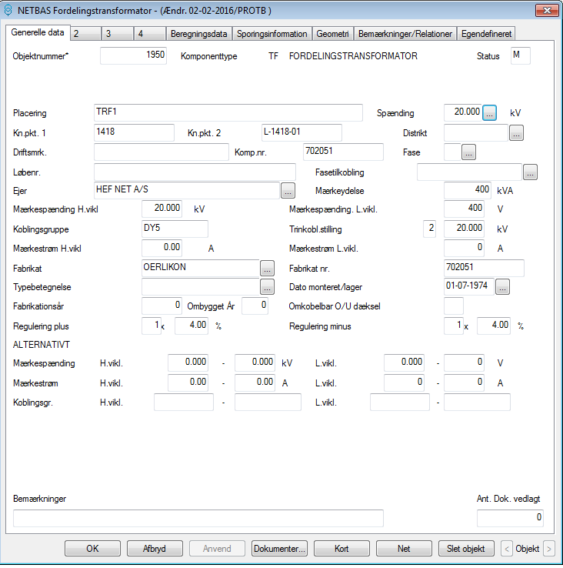

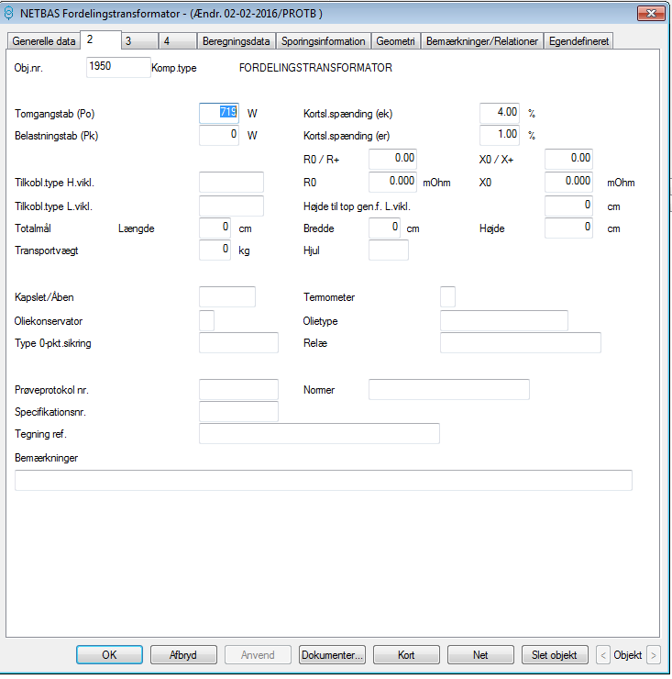

Kabelskabe med tilsluttede abonnenter

|  |  |
| --- | --- |
| Driftsmærkning | Antal tilsluttede AB |
| 49295 | 2 |
| 49291 | 1 |
| 37349 | 4 |
| 37348 | 2 |
| 37347 | 1 |
| 37344 | 4 |
| 37343 | 4 |
| 37342 | 4 |
| 37341 | 3 |
| 37340 | 4 |
| 37339 | 2 |
| 37338 | 2 |
| 37337 | 2 |
| 37336 | 4 |
| 37335 | 4 |
| 37334 | 4 |
| 37333 | 3 |
| 37332 | 3 |
| 37331 | 1 |
| 37330 | 2 |
| 37329 | 3 |
| 37327 | 2 |
| 37326 | 2 |
| 37325 | 1 |
| 37324 | 3 |
| 37323 | 3 |
| 37322 | 4 |
| 37321 | 0 |
| 37320 | 3 |
| 37319 | 2 |
| 37318 | 1 |
| 37317 | 2 |
| 37316 | 2 |
| 37315 | 3 |
| 37314 | 4 |
| 37313 | 1 |
| 37312 | 2 |
| 37311 | 2 |
| 37310 | 3 |
| 37309 | 0 |
| 22585 | 1 |
| 22584 | 0 |
| 22583 | 1 |
| 22582 | 1 |
| 22581 | 2 |
| 22580 | 1 |
| 22579 | 0 |